**Test Plan:**

**Google Translate**



**Created By: W Shanali Nipunika Fernando**

**Date: 15/03/2024**

**Table of Contents**

**1.** **Introduction** 1

**2.** **Scope** 2

**3.** **Objectives** 3

**4.** **Testing Approach** 3

**5.** **Test Environment** 4

**6.** **Test Cases** 4

**7.** **Risks and Assumptions** 6

**8.** **Deliverables** 6

**Conclusion** 7

**Table of Figures**

Figure 1: Website to Test: https://translate.google.com/ 1

# **Introduction**

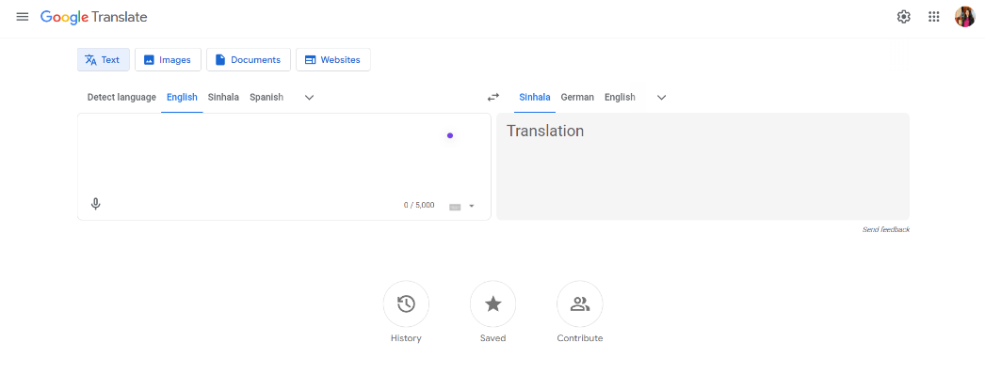This document outlines the steps and procedures for ensuring the reliability, accuracy, and efficiency of Google Translate, a vital tool for users seeking translation services across various languages.

Figure : Website to Test: [https://translate.google.com/](%20https:/translate.google.com/)

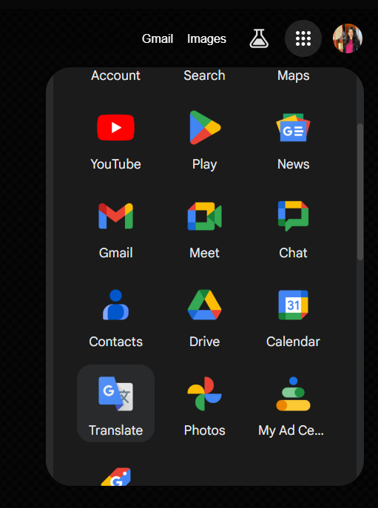Google Translate plays a crucial role in breaking down language barriers, enabling seamless communication and understanding across diverse linguistic landscapes. As part of this test plan, our focus is to meticulously examine and evaluate the functionality of Google Translate's user interface (UI) across different languages.

This test plan draft specifically targets the scope of testing three languages—English, Sinhala, and Tamil—across all UI functions. The primary goal is to identify and address any bugs or inconsistencies that may affect the user experience or translation accuracy.

It's worth noting that Google Translate is integrated into Google's suite of apps, making it easily accessible to users with a Google account. For new users, understanding how to navigate and utilize this function efficiently is crucial. Therefore, our testing efforts aim to ensure a smooth and intuitive experience for both new and experienced users alike.

As Quality Assurance (QA) professionals, our initial focus is to thoroughly test and validate the functionality of Google Translate to ensure its reliability and effectiveness in bridging language barriers.

1. **Scope**

The testing scope encompasses a wide range of functionalities within Google Translate, ensuring thorough evaluation of its capabilities.

This includes:

* Basic functionality testing to ensure Google Translate operates as intended.
* User interface testing to ensure ease of use and navigation.
* Language support testing across different languages, with a focus on English, Sinhala, and Tamil.
* Translation accuracy testing to confirm the correctness of translations.
* Special characters handling testing to ensure proper translation of non-standard characters.
* Long text handling testing to ensure accurate translation of lengthy texts.
* Language detection testing to verify the ability to identify input languages accurately.
* Offline functionality testing to assess performance without an internet connection.
* Audio translation testing to check the accuracy of spoken translations.
* Input methods testing to assess various text input methods.
* Browser compatibility testing to confirm functionality across different web browsers.
* Performance testing to evaluate response times.
* Text, image, document, and website translation testing to assess translation accuracy and output correctness.

This expanded scope ensures comprehensive testing of Google Translate across various translation methods, including text, image, document, and website translation, focusing on English, Sinhala, and Tamil language pairs. The goal is to evaluate the correctness and accuracy of the translation output across different input types and scenarios.

# **Objectives**

The objectives of this test plan are:

* To verify the accuracy and reliability of translations in Google Translate across multiple languages, including English, Sinhala, and Tamil.
* To ensure the user interface is responsive, intuitive, and consistent across different browsers and devices, facilitating a seamless translation experience.
* To confirm that Google Translate supports a wide range of languages and effectively handles special characters, long texts, and various language nuances.
* To identify and report any functional defects, compatibility issues, performance degradation, security vulnerabilities, and accessibility barriers encountered during testing.

# **Testing Approach**

Testing will primarily employ manual methods, incorporating predefined test cases and exploratory testing techniques. The approach will encompass a broad spectrum of Google Translate's functionality, not limited solely to translation accuracy but also extending to assessing UI responsiveness, language support, document handling, website translation capability, and performance under diverse conditions.

Moreover, it's essential to note that Google Translate isn't restricted solely to English translation. While the initial scope focuses on translating English, Sinhala, and Tamil, testing will also cover translation between Sinhala and Tamil, as well as between these languages and English. This comprehensive approach ensures thorough evaluation of Google Translate's capabilities across various language pairs.

# **Test Environment**

* Testing will be conducted on the following environments:
* Operating Systems: Windows, macOS
* Browsers: Chrome, Firefox, Safari
* Devices: Laptop, Mobile
* Internet Connectivity: High-speed internet connection

# **Test Cases**

**Text Translation Testing:**

* Untranslated text: Checking if some words are not translated.
* Special character encoding issues: Ensuring special characters are displayed correctly.
* Grammar and syntax errors: Checking for mistakes in the translated text.
* Contextual understanding: Verifying Google Translate understands the context of sentences.
* Text formatting loss: Checking if bold, italic, etc., formatting is retained.
* Incomplete translations: Ensuring long texts are fully translated.
* Clarity of translations: Checking if translations can be understood clearly.
* Language differences: Testing if different versions of a language are translated correctly.
* Unsupported language pair: Testing translations between languages not officially supported.

**Image Translation Testing:**

* Translation accuracy: Confirming that text within images is accurately translated.
* Special characters handling: Checking if special characters within images are translated properly.
* Contextual understanding: Verifying Google Translate understands the context of text within images.
* Language versions : Testing if different versions of a language within images are translated correctly.
* Unsupported language pair: Testing translations of text within images between languages not officially supported.

**Document Translation Testing:**

* Translation accuracy: Confirming that text within documents is accurately translated.
* Special characters handling: Checking if special characters within documents are translated properly.
* Grammar and syntax errors: Ensuring translated text within documents is grammatically correct.
* Contextual understanding: Verifying Google Translate understands the context of text within documents.
* Language variants: Testing if different versions of a language within documents are translated correctly.
* Unsupported language pair: Testing translations of text within documents between languages not officially supported.

**Website Translation Testing:**

* Translation accuracy: Confirming that the entire web page is accurately translated.
* Special characters handling: Checking if special characters within the website content are translated properly.
* Contextual understanding: Verifying Google Translate understands the context of the website content.
* Language variants: Testing if different versions of a language within the website content are translated correctly.
* Unsupported language pair: Testing translations of the website content between languages not officially supported.

**Other Testing:**

* History of Google Translate Page: Verify that the "History of Google Translate" page loads correctly.
* About Google Translate Page: Verify that the "About Google Translate" page loads properly.
* Privacy and Terms Page: Verify that the "Privacy and Terms" page loads without any errors.
* Help Page: Verify that the "Help" page loads and works properly.
* Send Feedback Functionality: "Send Feedback" and ensure the feedback form loads and works correctly.

# **Risks and Assumptions**

**Risks:**

1. Translation Accuracy: There's a risk of inaccuracies in translations to Sinhala and Tamil, which may lead to misunderstandings or incorrect interpretations.
2. Language Nuances: Translating into Sinhala and Tamil might miss the nuances or cultural context, impacting the meaning and clarity of the translated content.
3. Technical Limitations: There could be technical challenges or limitations in accurately translating complex English documents into Sinhala and Tamil, affecting the quality of the translated output.

**Assumptions:**

1. Translation Integrity: We assume that the translation engine for Sinhala and Tamil maintains the correctness and fidelity of the original text during translation.
2. Linguistic Understanding: It's assumed that the translation tool comprehensively understands the grammar, syntax, and semantics of both English and Sinhala/Tamil languages for accurate translation.
3. Compatibility: We expect the translated content to be compatible with Sinhala and Tamil language conventions and script, ensuring readability and coherence for users.

# **Deliverables**

* Test Plan Document
* Test Case Document
* Bug Reports
* Test Summary Report

# **Conclusion**

The test plan provides a thorough framework for testing the Google Translate web application, focusing on critical areas like text, image, document, and website translation. By including test cases for translation accuracy, special characters, context understanding, and language variants, the aim is to ensure Google Translate functions reliably across different languages and scenarios.

Furthermore, the plan outlines the testing approach, scope, and objectives to ensure a dependable and user-friendly translation experience. This version covers the main aspects of Google Translate testing. Subsequent iterations will delve deeper into specific test cases and scenarios to ensure thorough testing.